Official league roster - Basketball
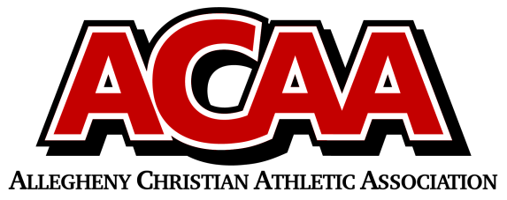

School Name: CACS
Team Colors: Black, White, Red
Overall Wins ___ Losses ____ Ties ___
ACAA Wins ___ Losses ____ Ties ___ OPPONENT: __________________________
Date: _________
Number | Name | Year | Position | Height | Homeschool
33 | Kaija Ramkawsky | 12 | F | 5’ 7’’
14 | Hannah Finney | 12 | F | 5”11”
23 | Lena Stone | 11 | F | 5’ 9’’
44 | Khloe McGarry | 11 | G | 5’ 7’’
22 | Myra Ramkawsky | 8 | F | 5’ 6’’
51 | Lily Mann | 8 | F | 5’ 6’’
5 | Adi Manno | 7 | G | 5’0”
43 | Solara Lopez | 7 | F | 5’5”
41 | Maya Joseph | 7 | C | 5’5”

Head Coach: Denise Smeal
Asst. coach: Elizabeth Shimmel
Asst. coach:

Official ACAA League Team Roster. to be submitted to the scorer’s table before each game.

